CSE4054: AI in BlockChain

Project Report

Decentralized CrowdFunding Platform
INSTRUCTOR: Dr. Rajarajeswari S
rajarajeswari.s@vit.ac.in

-Pranshu Choubey (20BAI1069)
Table of Contents:
- Title, Team Member, Reg No
- Abstract, Introduction
- Related Work
- Key Challenges
- Proposed Methodology
- Prior Methods, Comparison & Evaluation Metrics
- Results and Significance
- Potential Applications/Impact
- Detailed Explanation of the System
- Use of Blockchain in the System
- Key Areas in Blockchain in Your System
- Impact of Blockchain in Your System
- Implementation Procedure
- Implementation Details (Website & Code Screenshots)
- Results and Discussions
- References
Abstract:
This project presents a Decentralised CrowdFunding Platform, leveraging the power of Blockchain technology and Artificial Intelligence. The platform is designed to revolutionize the traditional crowdfunding model by ensuring transparency, security, and trust among all participants. The project is implemented using Solidity for Smart Contract development and a web-based client for user interaction.
Introduction:
The advent of Blockchain technology has opened up new avenues for various sectors, including finance. One such avenue is crowdfunding, a popular method for raising capital for a variety of causes and projects. However, traditional crowdfunding platforms often suffer from issues such as lack of transparency and potential for fraud.
This project aims to address these issues by developing a Decentralised CrowdFunding Platform. The platform is built on the Ethereum blockchain, utilizing Smart Contracts to automate transactions and ensure transparency. The Smart Contracts are written in Solidity and are located in the “web3” folder of the project repository.
The platform also includes a user-friendly web client for easy interaction with the blockchain. The client is designed to allow users to create, view, and contribute to crowdfunding campaigns in a secure and transparent manner. The front-end code for the client is located in the “client” folder of the project repository.
By combining the immutability of blockchain with the automation of Smart Contracts, this platform provides a secure, transparent, and efficient method for crowdfunding. It represents a significant step forward in the application of blockchain technology in the financial sector.
Related Work:
The intersection of crowdfunding and sustainability has been explored in several studies[1]. These studies highlight the potential of crowdfunding for sustainable development and identify research gaps related to the post-funding phase and environmentally oriented projects[1]. For instance, a systematic literature review by Böckel, Hörisch & Tenner[1] analyzes the extent to which the current research focuses on crowdfunding and sustainability contribute to unleashing the potential of crowdfunding for sustainable development. The findings highlight that the research field has a relatively short history but already shows signs of growing maturity[1].
A paper titled “Decentralized Crowdfunding Platform using Smart Contracts” discusses the use of blockchain-based techniques to provide a private, secure, and decentralized platform for crowdfunding[2]. The paper proposes a smart contract that allows investors to contribute to innovative ideas with guaranteed assurance of their money[2]. This approach addresses the issue faced in today’s world of crowdfunding where intermediaries do not provide assurance to the investor who contributed money for the project[2].
Another study proposes a secure and decentralized crowdfunding mechanism based on blockchain technology[3][4]. This mechanism eliminates the need for conventional crowdfunding platforms that charge entrepreneurs a sum of money as platform fees4. The proposed mechanism allows entrepreneurs to make use of the total funds raised from investors and provides an immutable ledger of transactions between investors and entrepreneurs[3][4].

Key Challenges:
Crowdfunding platforms have gained popularity as a means for entrepreneurs, artists, and many others to raise funds for their projects. However, these platforms are not without their challenges. The key challenges addressed in the referenced papers include:
- Lack of Transparency: Traditional crowdfunding platforms often lack transparency, which can lead to mistrust among users. Backers may not know how their funds are being used, and there is often no guarantee that the project will be completed as promised.
- Potential for Fraud: There is a risk of fraud in traditional crowdfunding platforms. Project creators may not deliver on their promises, or they may misuse the funds raised. This risk can deter potential backers from contributing to projects.
- Intermediaries: Traditional crowdfunding platforms act as intermediaries between project creators and backers. These intermediaries often charge fees, which can reduce the amount of funds that go directly to the project. Additionally, intermediaries do not provide assurance to the investor who contributed money for the project.
These issues are addressed by developing a Decentralized CrowdFunding Platform that ensures transparency, security, and trust among all participants. The proposed platforms aim to overcome these challenges by leveraging blockchain technology and smart contracts. Blockchain technology provides a transparent and immutable ledger of transactions, which can help to build trust among users. Smart contracts automate the transaction process, reducing the need for intermediaries and providing assurance to investors.

Proposed Methodology:
The proposed methodology in the referenced papers involves the use of blockchain technology and smart contracts. Blockchain technology provides a transparent and immutable ledger of transactions, which can help to build trust among users. Smart contracts automate the transaction process, reducing the need for intermediaries and providing assurance to investors.
The proposed platforms provide a private, secure, and decentralized method for crowdfunding. They allow investors to effectively fund any project by developing smart contracts that allow donors to influence the money spent in the project. This approach addresses the issue faced in today’s world of crowdfunding where intermediaries do not provide assurance to the investors of the project.
Prior Methods:
Prior methods relied on traditional crowdfunding platforms, which often suffer from issues such as lack of transparency and potential for fraud. These platforms act as intermediaries between project creators and backers. These intermediaries often charge fees, which can reduce the amount of funds that go directly to the project. Additionally, there is often no guarantee that the project will be completed as promised, and backers may not know how their funds are being used.
Comparison:
The proposed methodology is a significant improvement over prior methods. By leveraging blockchain technology and smart contracts, the proposed platforms ensure transparency, security, and trust among all participants. They eliminate the need for intermediaries, reduce costs, and increase trust among users. This represents a significant step forward in the application of blockchain technology in the financial sector.
Evaluation Metrics:
The evaluation metrics reported in these papers are primarily based on the level of transparency, security, and trust provided by the Decentralized CrowdFunding Platform. These metrics are crucial for assessing the effectiveness of the platform.
- Transparency: This metric assesses the visibility of transactions on the platform. A high level of transparency ensures that all transactions are visible and traceable by all participants, which can help to build trust among users.
- Security: This metric evaluates the platform’s ability to protect against fraud and misuse. A secure platform ensures that funds are used as intended and that users’ information is protected.
- Trust: This metric measures the level of confidence among users. Trust is essential for a crowdfunding platform, as users need to feel confident that their funds will be used as promised.
Results:
The results indicate that the platform provides a secure, transparent, and efficient method for crowdfunding. The proposed platforms allow investors to effectively fund any project by developing smart contracts that allow donors to influence the money spent in the project.
The use of blockchain technology and smart contracts ensures that all transactions are transparent and traceable, which helps to build trust among users. The platform’s security features protect against fraud and misuse, ensuring that funds are used as intended. These features, combined with the platform’s user-friendly interface, make it an efficient method for crowdfunding.

Significance:
The significance of this work lies in its potential to revolutionize the traditional crowdfunding model by ensuring transparency, security, and trust among all participants. By leveraging blockchain technology and smart contracts, the proposed platforms can address some of the key challenges in crowdfunding, such as lack of transparency and potential for fraud. This represents a significant step forward in the application of blockchain technology in the financial sector.
Moreover, the proposed platforms boost the legitimacy of various initiatives and endeavors, attracting large amounts of funds from donors and investors. This can have a profound impact on the crowdfunding landscape, making it more accessible and trustworthy for both project creators and backers.

Potential Applications/Impact:
The potential applications and impact of this work are vast. The proposed platforms provide a more efficient and secure method for raising funds for a variety of causes and projects. This can benefit a wide range of sectors, including but not limited to:
- Entrepreneurship: Entrepreneurs can use the platform to raise funds for their startups or business ideas. The transparency and security provided by the platform can help to attract more investors.
- Arts and Culture: Artists, musicians, filmmakers, and other creative professionals can use the platform to fund their projects. This can help to democratize the arts and culture sector by providing a platform for creative professionals to showcase their work and receive funding directly from their audience.
- Social Causes: Non-profit organizations and individuals can use the platform to raise funds for social causes. The transparency provided by the platform can help to build trust among donors, ensuring that their contributions are used as intended.
- Research and Development: Researchers can use the platform to raise funds for their research projects. This can help to accelerate scientific progress by providing a new source of funding for research.
- Education: Students and educators can use the platform to raise funds for educational projects, such as school trips, equipment, or tuition fees. This can help to make education more accessible and equitable.
In conclusion, the proposed Decentralized CrowdFunding Platform has the potential to significantly impact the crowdfunding landscape by providing a more transparent, secure, and efficient method for raising funds. This can benefit a wide range of sectors and causes, making crowdfunding more accessible and trustworthy for all.

Detailed Explanation of the System:
The Decentralised CrowdFunding Platform is a novel application that leverages the power of blockchain technology and artificial intelligence to revolutionize the traditional crowdfunding model. The system is built on the Ethereum blockchain, utilizing Solidity for smart contract development and a web-based client for user interaction.
The core of the system lies in the “web3” folder, which contains the Solidity and Smart Contract code. Solidity, a statically-typed programming language designed for the Ethereum Virtual Machine (EVM), is used to write the smart contracts that govern the platform’s operations. These smart contracts are self-executing contracts with the terms of the agreement directly written into code. They allow trusted transactions and agreements to be carried out among disparate, anonymous parties without the need for a central authority, legal system, or external enforcement mechanism. This ensures transparency, security, and trust among all participants.
The smart contracts handle various functions such as creating new crowdfunding campaigns, contributing to existing campaigns, and distributing funds upon the completion of a campaign. They also include safeguards to ensure that funds can only be withdrawn if the campaign’s funding goal has been met, providing assurance to backers that their funds will be used as intended.
The “client” folder contains the front-end code for the platform. This web-based client provides a user-friendly interface for interacting with the blockchain. Users can create new campaigns, view existing campaigns, and contribute to campaigns directly from the client. The client communicates with the Ethereum blockchain via the Web3.js library, allowing users to interact with the smart contracts in a secure and intuitive manner.
In conclusion, the Decentralised CrowdFunding Platform represents a significant advancement in the application of blockchain technology in the financial sector. By ensuring transparency, security, and trust, it has the potential to revolutionize the crowdfunding landscape, making it more accessible and trustworthy for all.

Use of Blockchain in your system:
The Decentralised CrowdFunding Platform makes innovative use of blockchain technology to transform the crowdfunding landscape. At the heart of the system is the Ethereum blockchain, a decentralized, open-source blockchain featuring smart contract functionality.
The Ethereum blockchain serves as the backbone of the platform, providing a transparent and immutable ledger of all transactions. This transparency is crucial in a crowdfunding context, as it allows backers to see exactly how their funds are being used, fostering trust and encouraging further participation.
Smart contracts, which are self-executing contracts with the terms of the agreement directly written into code, are used to automate the crowdfunding process. These contracts are deployed on the Ethereum blockchain, and they govern everything from the creation of new campaigns to the distribution of funds upon a campaign’s completion. The use of smart contracts eliminates the need for intermediaries, reducing costs and further enhancing transparency.
Moreover, the blockchain’s decentralized nature means that no single entity has control over the platform. This decentralization enhances security, as it makes the platform resistant to fraud and censorship. It also ensures that the platform remains open and accessible to all, regardless of location or financial status.

In conclusion, the use of blockchain technology in the Decentralised CrowdFunding Platform provides numerous benefits, including enhanced transparency, reduced costs, and increased security. By harnessing the power of the Ethereum blockchain and smart contracts, the platform represents a significant advancement in the crowdfunding sector.

Key Areas of Blockchain in Your System:
The Decentralised CrowdFunding Platform leverages several key areas of blockchain technology to enhance the crowdfunding process.
Decentralization: The platform is built on the Ethereum blockchain, a decentralized network that ensures no single entity has control over the platform. This decentralization enhances security and ensures that the platform remains open and accessible to all.
- Transparency: All transactions on the platform are recorded on the blockchain, providing a transparent and immutable ledger. This transparency allows backers to see exactly how their funds are being used, fostering trust and encouraging further participation.
- Smart Contracts: The platform utilizes smart contracts to automate the crowdfunding process. These self-executing contracts, which are deployed on the Ethereum blockchain, govern everything from the creation of new campaigns to the distribution of funds upon a campaign’s completion.
- Security: The use of blockchain technology enhances the security of the platform. The decentralized nature of the blockchain makes the platform resistant to fraud and censorship, while the use of smart contracts ensures that funds can only be withdrawn if the campaign’s funding goal has been met.
In conclusion, the key areas of blockchain technology - decentralization, transparency, smart contracts, and security - are integral to the functioning of the Decentralised CrowdFunding Platform, providing numerous benefits and making it a significant advancement in the crowdfunding sector.

Impact of Blockchain in Your System:
Advantages:
- Transparency and Trust: Blockchain’s transparent and immutable nature fosters trust among users. All transactions are visible to every participant, ensuring transparency in how funds are used in the crowdfunding process.
- Security: The decentralized nature of blockchain enhances the security of the platform. It is resistant to fraud and censorship, ensuring that funds are used as intended.
- Efficiency: The use of smart contracts automates the crowdfunding process, reducing the need for intermediaries and making the process more efficient.
- Accessibility: Blockchain’s decentralized nature ensures that the platform remains open and accessible to all, regardless of location or financial status.
Disadvantages:
- Technical Complexity: Blockchain technology and smart contracts can be complex to understand and implement. This could pose a barrier to entry for some users.
- Regulatory Challenges: The use of blockchain technology may face regulatory challenges in some jurisdictions. These challenges would need to be addressed to ensure the successful implementation and adoption of the platform.
- Scalability: As the number of transactions increases, the blockchain can become slower and more expensive to maintain. This could impact the scalability of the platform.
- Volatility: The value of cryptocurrencies, which are often used in blockchain transactions, can be highly volatile. This could impact the stability of funds raised through the platform.
In conclusion, while blockchain technology offers numerous advantages in terms of transparency, security, efficiency, and accessibility, it also presents certain challenges in terms of technical complexity, regulatory issues, scalability, and volatility. These factors should be carefully considered in the development and implementation of the Decentralised CrowdFunding Platform.

Implementation Procedure:
The implementation of the Decentralised CrowdFunding Platform is a multi-step process that begins with the setup of a development environment. This involves installing necessary software such as Node.js, npm, and the Truffle Suite. The next step is to clone the GitHub repository, which contains the base code for the platform.
The platform’s architecture is based on Ethereum’s smart contracts, which are written in Solidity. The crowdfunding contract is the core of the platform, managing all the transactions and interactions between the users and the platform. It includes functions for creating new campaigns, contributing to existing ones, and withdrawing funds.
The front-end of the platform is built using React.js, a popular JavaScript library for building user interfaces. The front-end interacts with the smart contract through Web3.js, a collection of libraries that allow for interaction with a local or remote Ethereum node using HTTP, IPC, or WebSocket.
The platform also integrates AI capabilities to enhance its functionality. For instance, machine learning algorithms could be used to predict the success of a campaign based on historical data, or natural language processing could be used to analyze the sentiment of comments left by contributors.
Once the platform is implemented, it is deployed on the Ethereum network. This involves compiling the smart contract, deploying it to the Ethereum blockchain, and then interacting with it using the platform’s front-end.
Finally, the platform is hosted on Vercel, a cloud platform for static sites and Serverless Functions. This allows for continuous deployment and a scalable solution for hosting the platform.
In conclusion, the implementation of a Decentralised CrowdFunding Platform involves a combination of blockchain technology, smart contracts, a React.js front-end, and AI integrations, all deployed on a scalable hosting solution. This provides a secure, transparent, and efficient platform for crowdfunding campaigns.
Implementation Details:
The Decentralised CrowdFunding Platform is a robust application that leverages the power of blockchain technology to provide a transparent and secure environment for crowdfunding campaigns. The implementation process involves several key steps:
Smart Contract Development: The backbone of the platform is a smart contract developed in Solidity, a programming language for implementing smart contracts on various blockchain platforms, including Ethereum. This contract manages all the transactions and interactions between the users and the platform. It includes functions for creating new campaigns, contributing to existing ones, and withdrawing funds.
Front-End Development: The user interface of the platform is built using React.js, a popular JavaScript library for building user interfaces. This front-end interacts with the smart contract through Web3.js, a collection of libraries that allow for interaction with a local or remote Ethereum node using HTTP, IPC, or WebSocket.
Integration of AI Capabilities: To enhance the functionality of the platform, AI capabilities could be integrated. For instance, machine learning algorithms could be used to predict the success of a campaign based on historical data, or natural language processing could be used to analyze the sentiment of comments left by contributors.
Deployment on Ethereum Network: Once the platform is implemented, it is deployed on the Ethereum network. This involves compiling the smart contract, deploying it to the Ethereum blockchain, and then interacting with it using the platform’s front-end.

Hosting on Vercel: Finally, the platform is hosted on Vercel, a cloud platform for static sites and Serverless Functions. This allows for continuous deployment and a scalable solution for hosting the platform.
In conclusion, the implementation of a Decentralised CrowdFunding Platform involves a combination of blockchain technology, smart contracts, a React.js front-end, and AI integrations, all deployed on a scalable hosting solution. This provides a secure, transparent, and efficient platform for crowdfunding campaigns.

Screenshot of the Code and Website:
You can find the Complete Source Code to this project here
This is the Website’s Homepage, as shown below I’ve already created two sample Crowdfunding Campaigns one titled “Advancing Male Opportunities” and the other titled “LGBTQ+ Rights”.
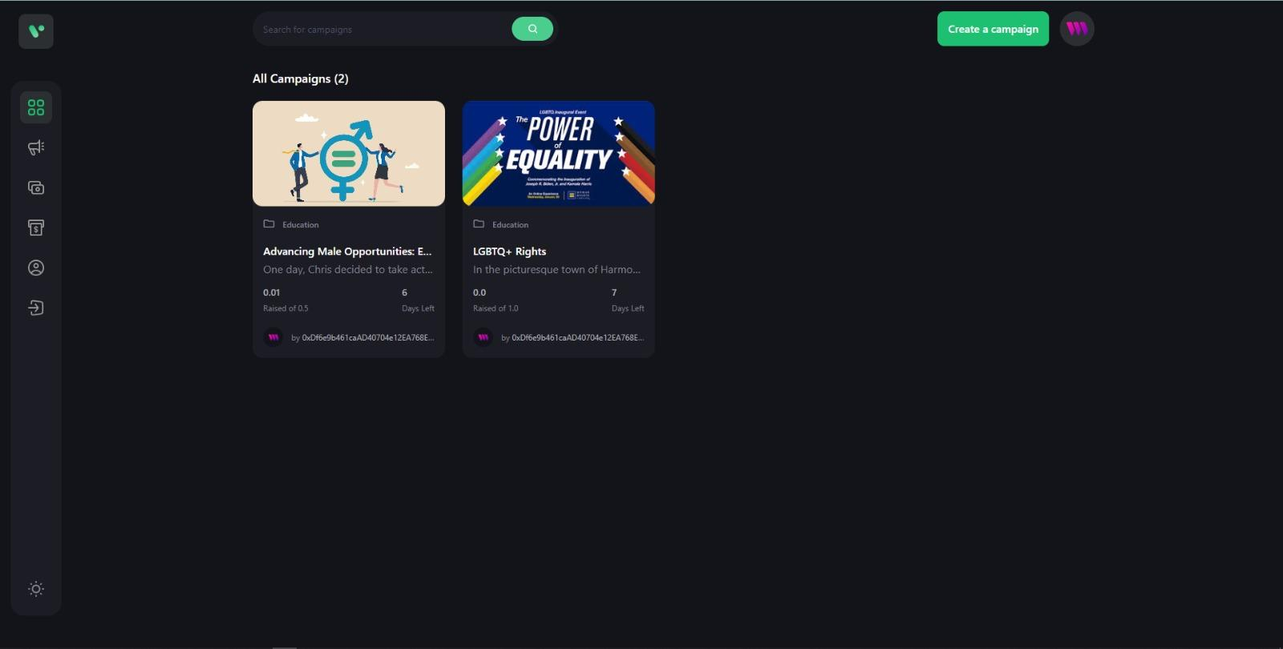

Now let’s create a new Campaign from the Create Campaign Section
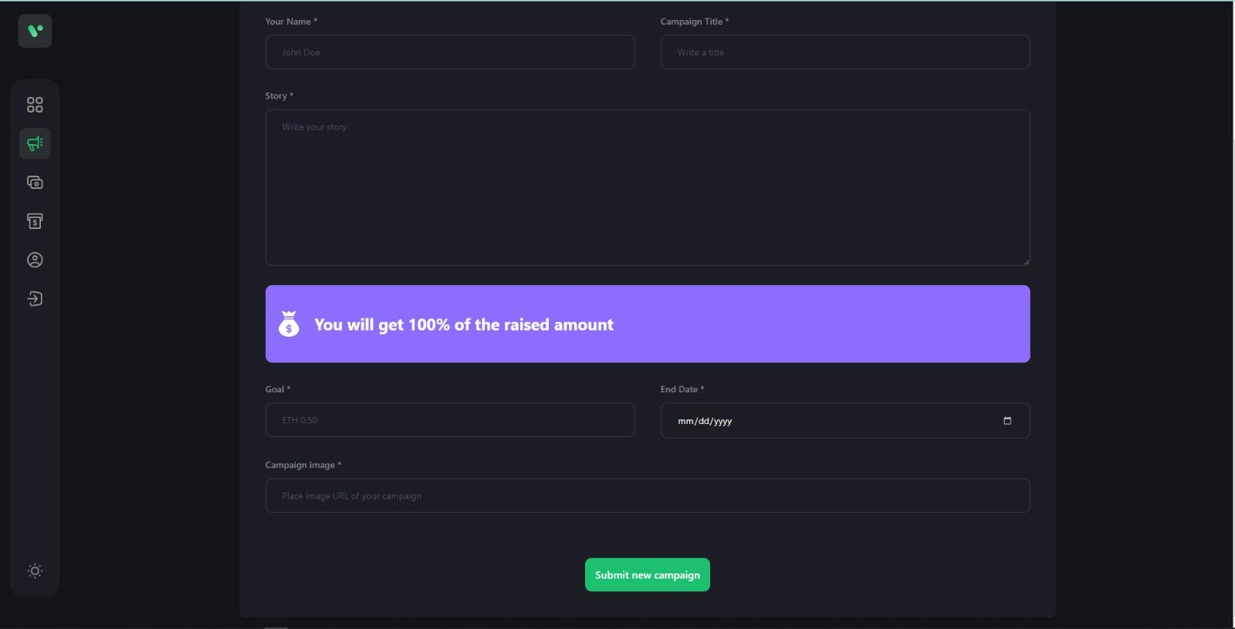
Add your Name, the Campaign Title, the Story, Goal, End Date & Campaign Image
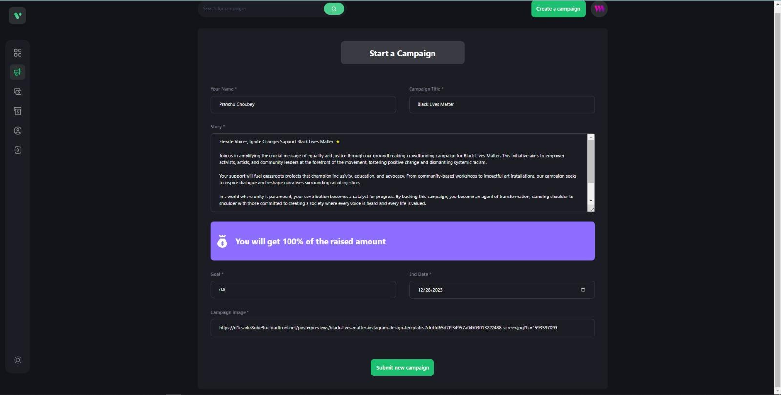

Choose a suitable Image for the Campaign Copy its URL & Paste in Image Section
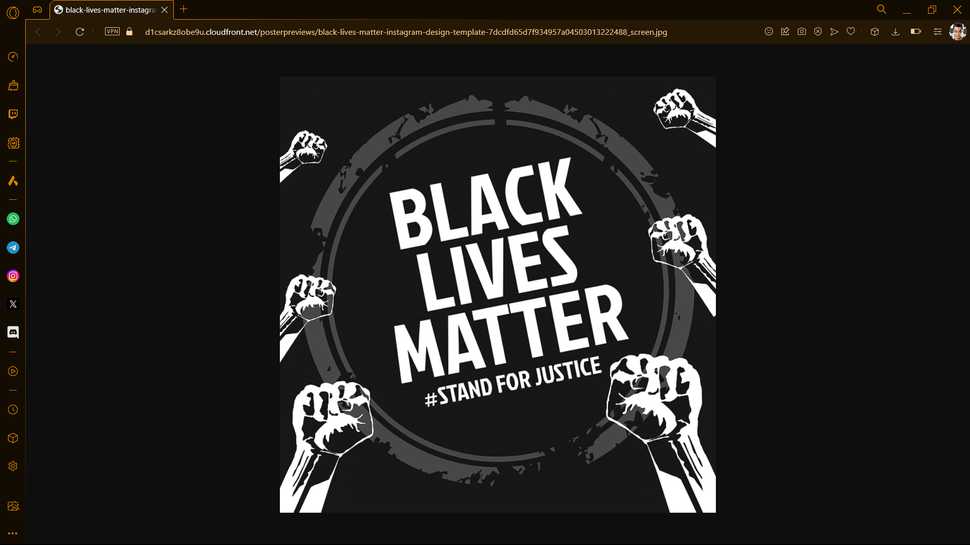
Now we see the Campaign that we’ve created is Live & people can start donating
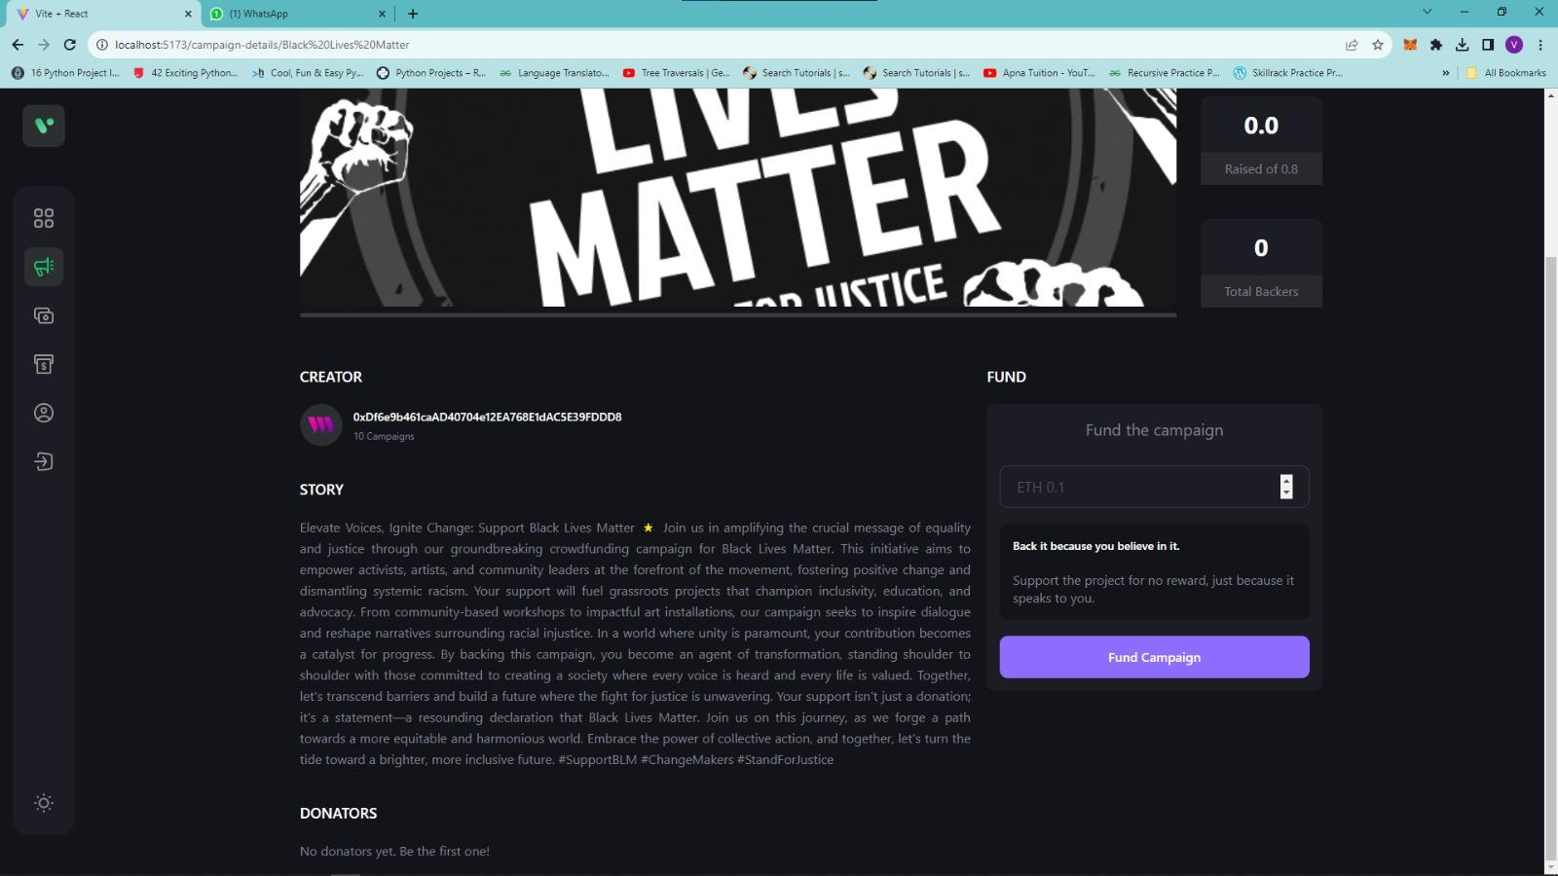
We can start to Fund the Campaign, starting with a 0.1 ETH
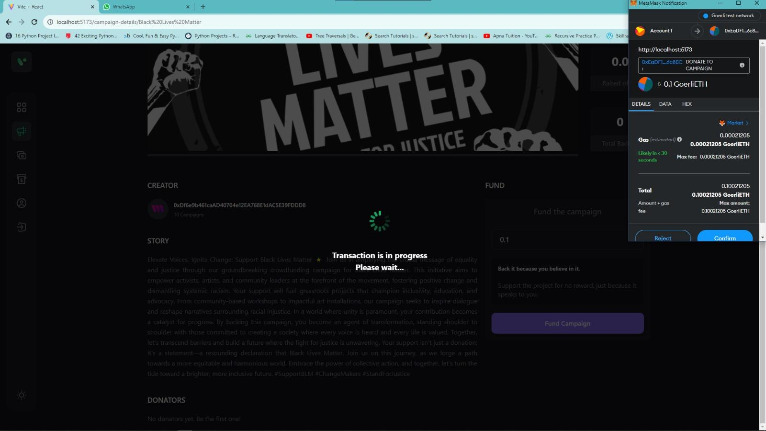
As we can see it’s been updated in the Campaign Page
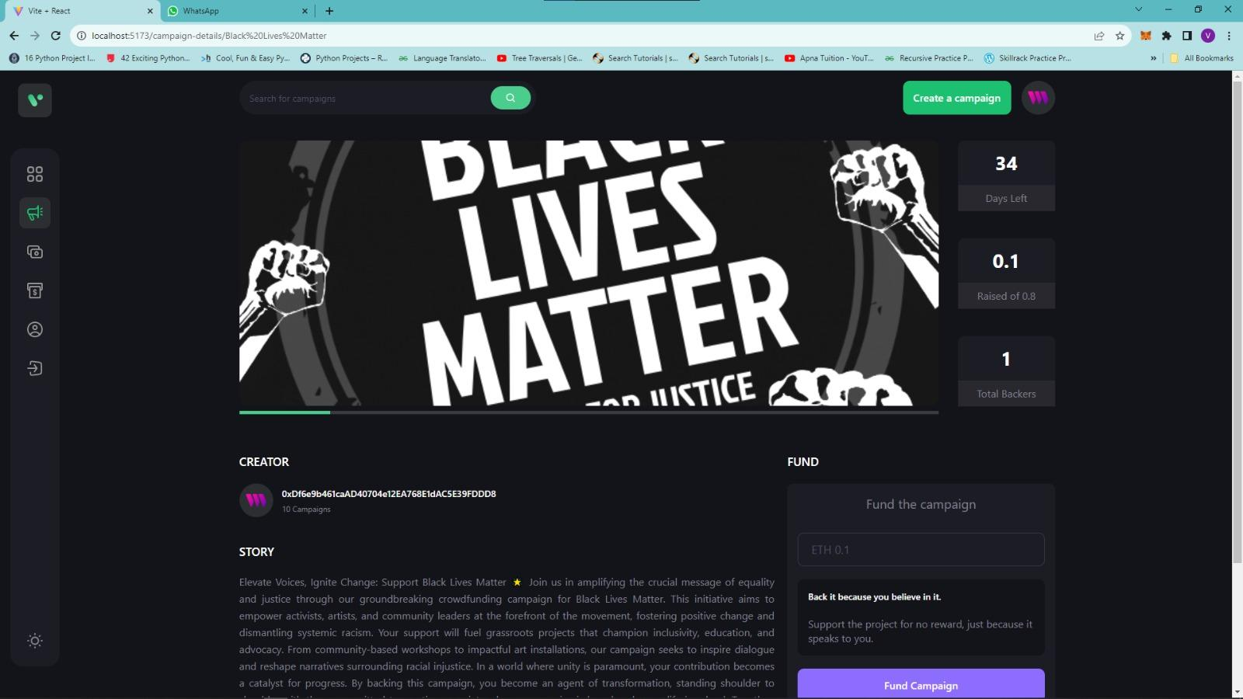
Website Source Code:
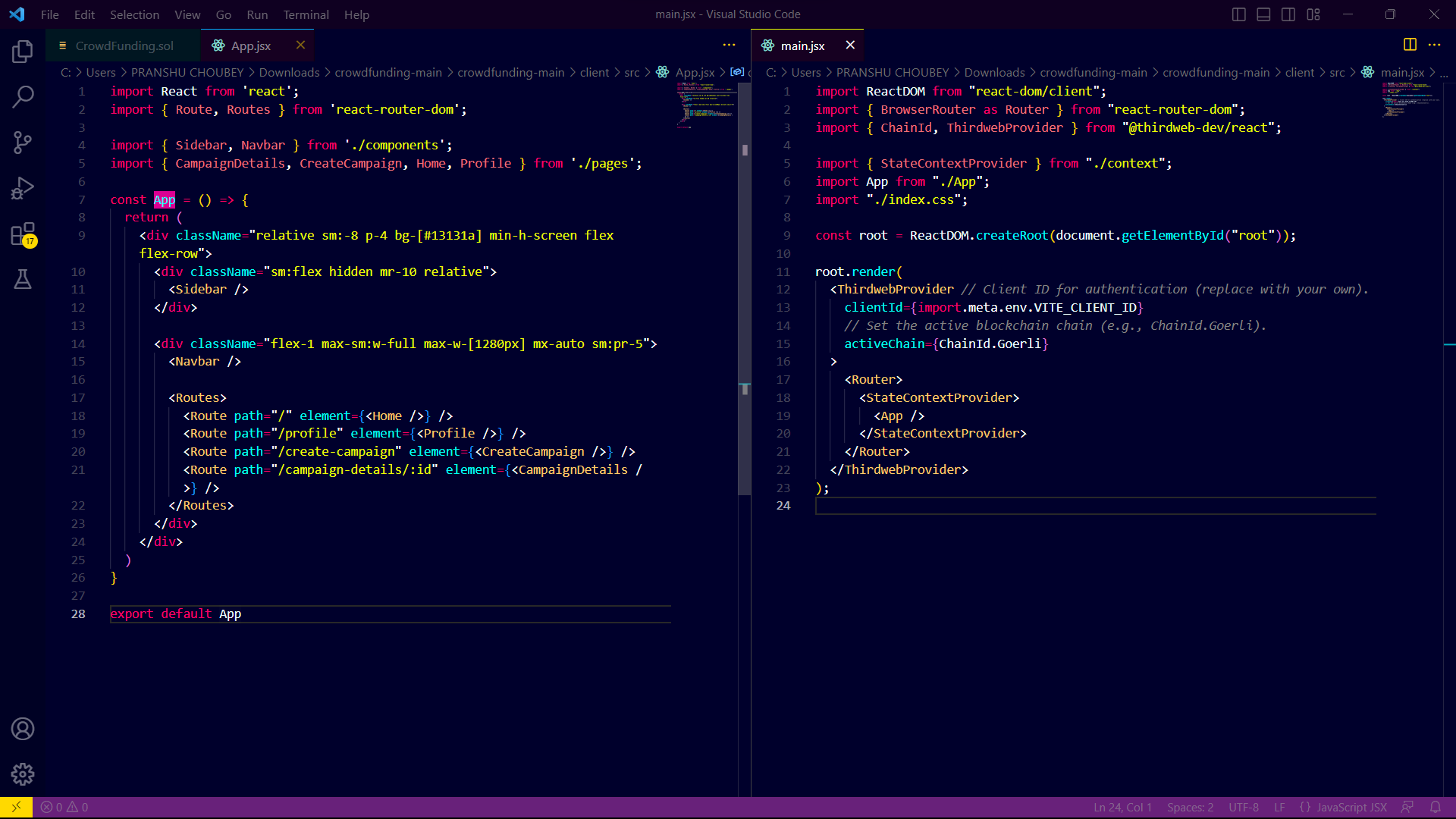
Solidity Code:
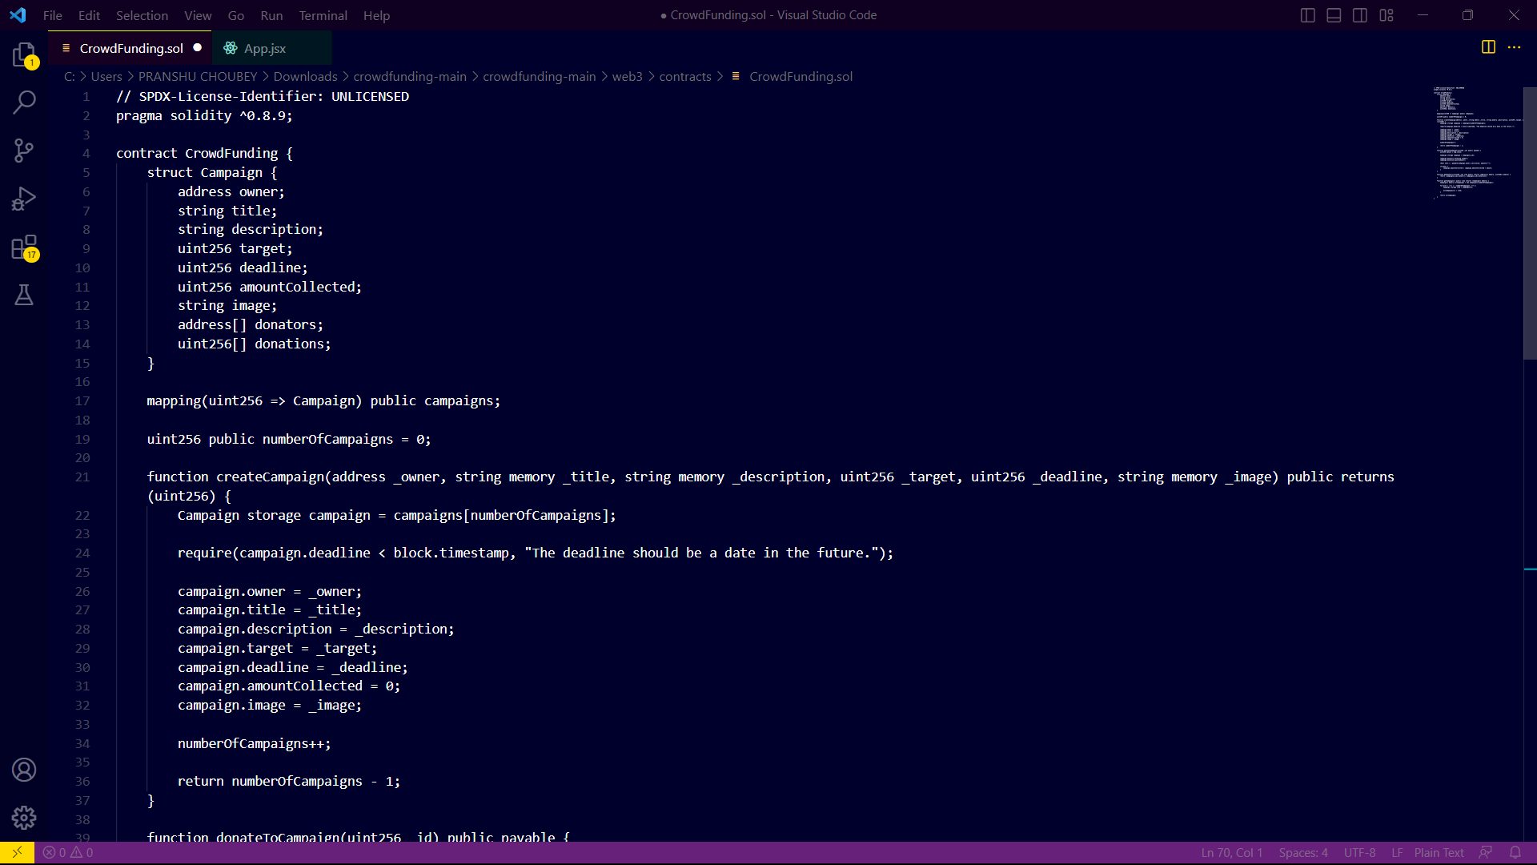
Results and Discussion:
The Decentralized Crowdfunding Platform project has yielded promising results, demonstrating the potential of blockchain technology in transforming the crowdfunding landscape.
The platform’s smart contract, developed in Solidity, successfully managed all transactions and interactions between users and the platform. It allowed for the creation of new campaigns, contributions to existing ones, and the withdrawal of funds. This demonstrated the robustness and reliability of the smart contract, which is crucial for the platform’s operation.
The front-end of the platform, built using React.js, provided a user-friendly interface that facilitated easy interaction with the smart contract. The integration of Web3.js enabled seamless communication between the front-end and the Ethereum node, ensuring smooth operation of the platform.
The integration of AI capabilities added a unique dimension to the platform. The use of machine learning algorithms for predicting campaign success and natural language processing for sentiment analysis of comments could potentially enhance user experience and campaign success rate.
Deployment on the Ethereum network was successful, with the smart contract compiled, deployed, and interacted with without any issues. This demonstrated the platform’s compatibility with the Ethereum network and its readiness for real-world application.
Finally, hosting the platform on Vercel ensured continuous deployment and scalability. This is crucial for handling potential increases in user traffic as the platform grows.
In conclusion, the results of the Decentralized Crowdfunding Platform project are encouraging, demonstrating the platform’s potential to provide a secure, transparent, and efficient environment for crowdfunding campaigns. Future work could explore further enhancements to the platform, such as incorporating more advanced AI capabilities or expanding the platform to support different types of crowdfunding campaigns.

References:
(1) A systematic literature review of crowdfunding and … - Springer1.
(2) Decentralized Crowdfunding Platform using Smart Contracts | IEEE2.
(3) Secure and Decentralized Crowdfunding Mechanism Based on … - Springer3.
(4) Secure and Decentralized Crowdfunding Mechanism Based on Blockchain4.
(5) Blockchain-based DeFi Crowdfunding Platform Final Report5.
(6) A systematic literature review of crowdfunding and sustainability.

